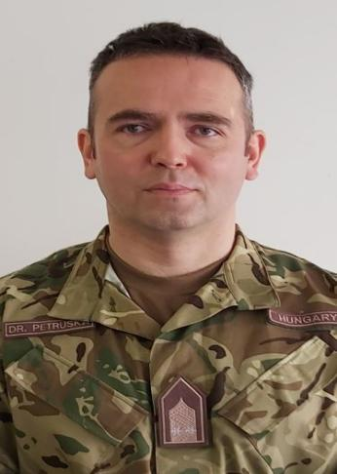
LtCol. Dr. Ferenc Petruska, PhD
Address: 9–11 Hungária Blvd., Budapest, H–1101
Email: petruska.ferenc@uni-nke.hu
Phone: +36 1 432 9000 / 29202
Place and Date of Birth: Szerencs, 21 March 1977
Nationality: Hungarian

PROFESSIONAL EXPERIENCE
2025 – present  2019 – present |  | Vice-Dean for International Affairs, Faculty of Military Sciences and Officer Training, Ludovika University of Public Service  Head of Department, Associate Professor, Department of Military Law and Administration, Ludovika University of Public Service
2015 – 2019 |  | Assistant Professor, Department of Military Law and Administration, Ludovika University of Public Service
2012 – 2015  2011  2010  2007 – 2010  2007  2005 – 2006  2001 – 2005  2001 |  | Legal Adviser, Faculty of Military Sciences and Officer Training, Ludovika University of Public Service  Lead Legal Counsel / Economic Legal Adviser, Miklós Zrínyi National Defence University  Legal Adviser, Ministry of Defence (MoD), Department of Defence Planning and Asset Management  Legal Counsel, MoD Development and Logistics Agency  Legal Counsel, MoD International and Event Management Office  Chief of Law and Administration, HDF 1st EOD and River Guard Regiment  Legal Officer, HDF 1st EOD and River Guard Regiment
EDUCATION
2012–2015 | PhD in Military Sciences, Doctoral School of Military Sciences, Ludovika University of Public Service
2006  2001 – 2006  1996 – 2001 | Public Procurement Specialist Certificate, SOTER Training Centre  Postgraduate Diploma in Capital Market and Banking Law, Pázmány Péter Catholic University, Deák Ferenc Institute  Juris Doctor (JD) in Law, Eötvös Loránd University (ELTE), Faculty of Law
OTHER ACADEMIC AND PROFESSIONAL ACTIVITIES
2019 – present  2018 – present | President of the Honvéd Zrínyi Sport Association  Member of the Hungarian Society for Military Law and the Law of War
STUDIES AND DEGREES
2019 |  |  | PhD in Military Sciences
LANGUAGE SKILLS
English |  | STANAG 6001 Level 3.3.3.3. (Professional Proficiency)
German |  | B1 (Intermediate)

